Ansible

**Aim**: - Create custom hosts inventory file, ansible-module and Playbook on ansible-controller using on azure portal

**Create a custom hosts inventory file, ansible-module and Playbook on ansible-controller using on azure portal**

To add demo group, ansible-hostnode IP, user id and password in ansible-controller host file by using the following the command:

#vi /etc/ansible/hosts

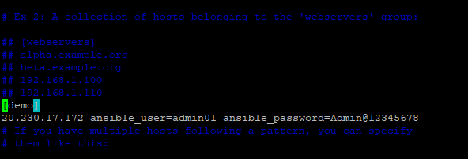

To check the ansible files file by using the following the command:

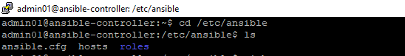

To check the ansible configuration file by using the following the command:

#cat /etc/ansible/ansible.cfg

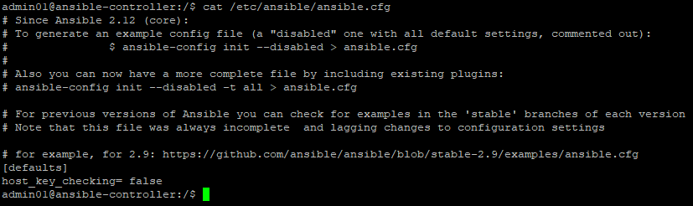

To check the disable SSH key host checking by using the following path:

https://github.com/ansible/ansible/blob/stable-2.9/examples/ansible.cfg

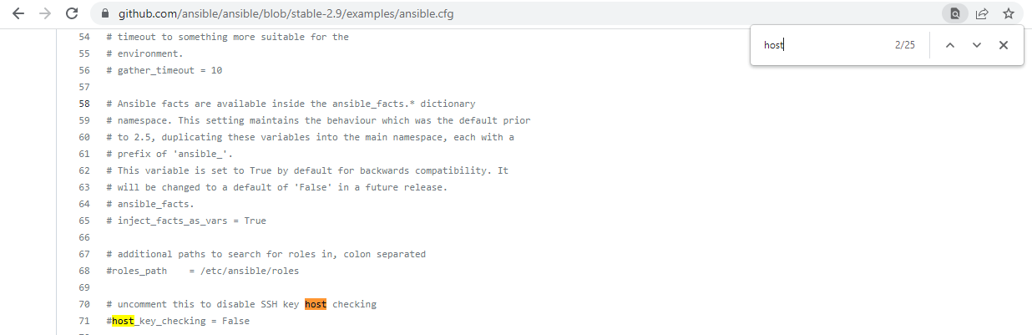

To ping the ansible-hostnode on ansible-controller by using the ansible module command:

$ansible demo –m ping

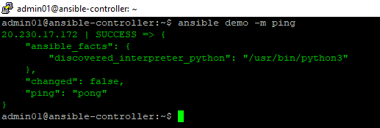

To create custom hosts inventory file by using the following the command:



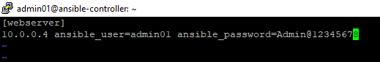

To ping the ansible-hostnode and hosts inventory file on ansible-controller by using the ansible module command:

$ansible webserver –m ping –i hosts

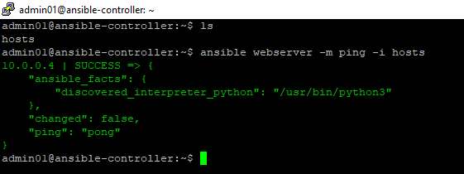

To check the default module command:

$cat /etc/ansible/ansible.cfg

https://github.com/ansible/ansible/blob/stable-2.9/examples/ansible.cfg

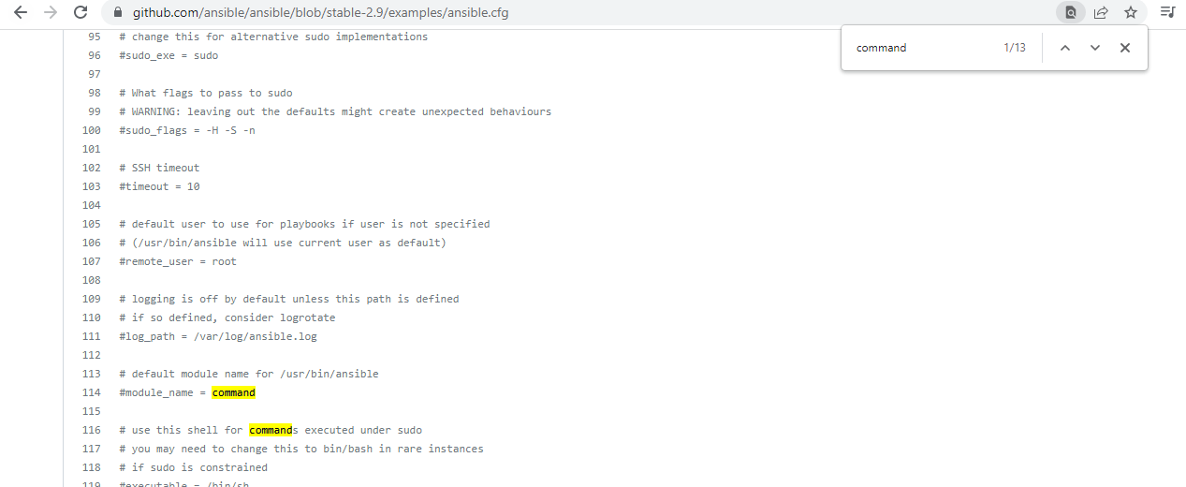

**Shell module:**

To check uptime ansible-hostnode by using the default module and custom inventory hosts module:

$ansible all –m command –a “uptime”

$ansible all –a “uptime” –i hosts

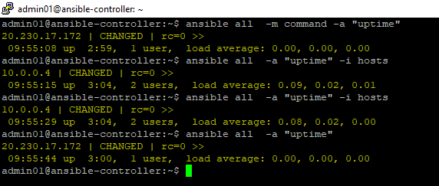

To check the default become privilege escalation:

$cat /etc/ansible/ansible.cfg

https://github.com/ansible/ansible/blob/stable-2.9/examples/ansible.cfg

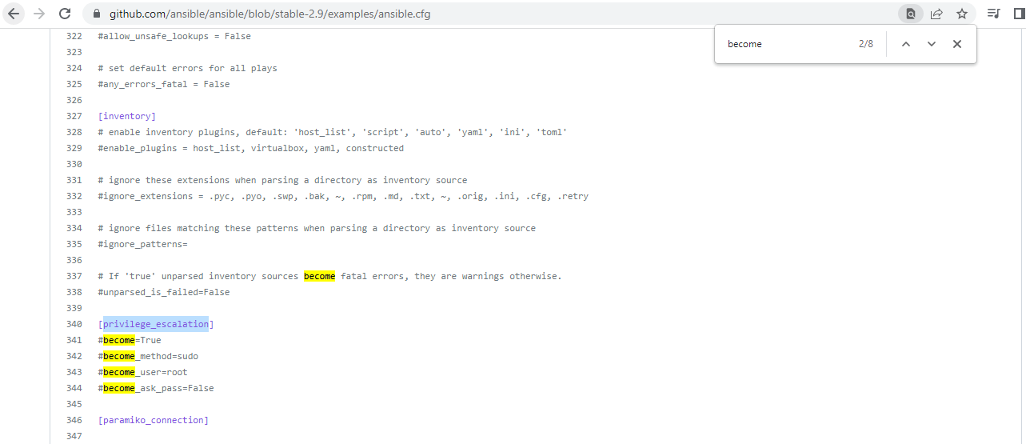

**Ansible AD_HOC commands:**

To display date from all host machines using the following command:

#ansible all –m shell –a date



To display the all the modules available in Ansible using the following command:

#ansible-doc -I

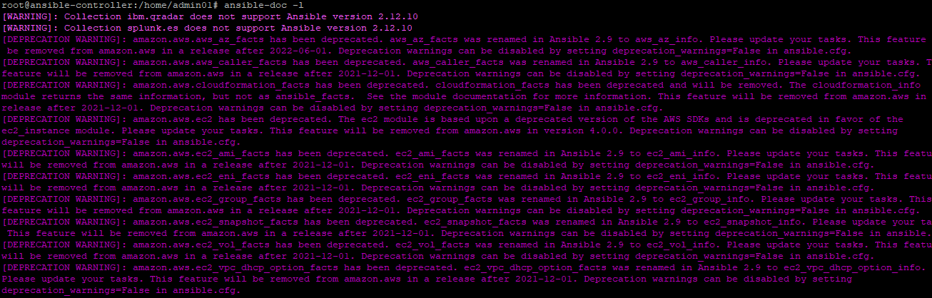

**APT Module:**

To install vim package in all node machine using the following command:

#ansible all -b -m apt -a "name=vim"

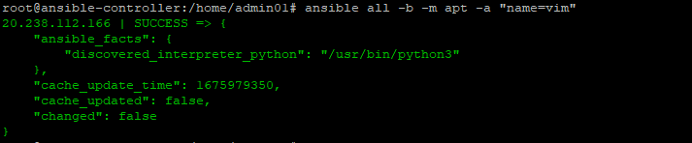

To install git package in local host using the following command:

#ansible localhost -b -m apt -a "name=git"

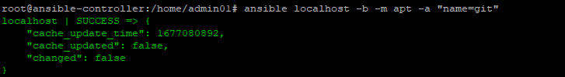

To install appache2 package in all node machines using the following command:

# ansible all -b -m apt -a "name=apache2 state=present"

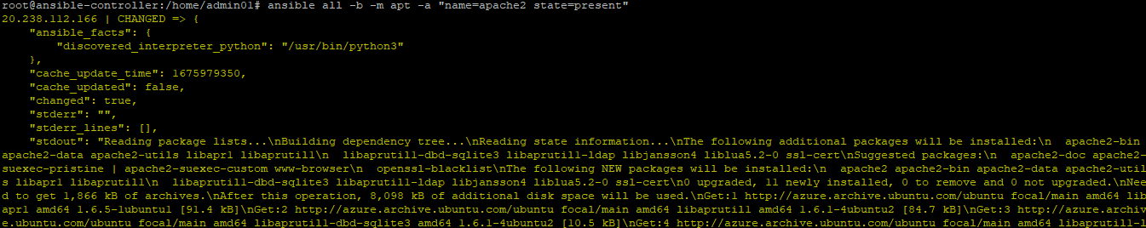

To install tree package in all node machines using the following command:

#ansible all -b -m apt -a "name=tree"

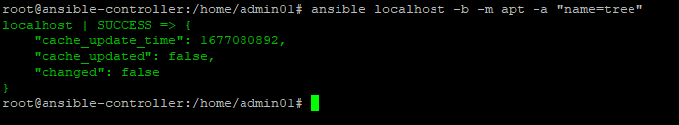

**Service Module:**

To started apache services in all node machine using the following command:

# ansible all -b -m service -a "name=apache2 state=started"

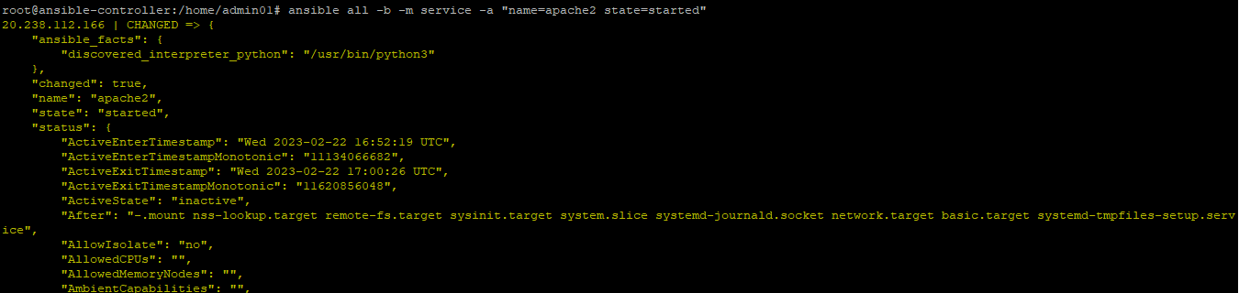

To started apache services in all node machine using the following command:

# ansible all -b -m service -a "name=apache2 state=stopped"

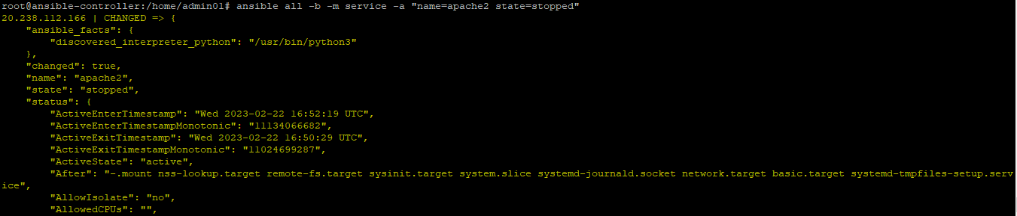

**Copy Module:**

To copy file src to dest in all node machine using the following command:

#ansible all -b -m copy -a "src=file4 dest=/tmp"

Ansible-controller:

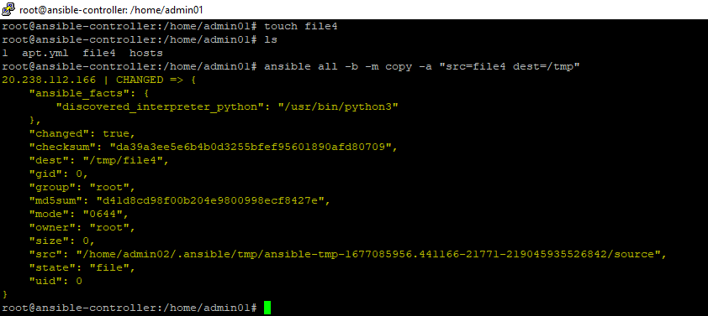

Ansible-hostnode:



**Setup Module:**

All facts about remote hostsusing the following command:

#ansible all -m setup

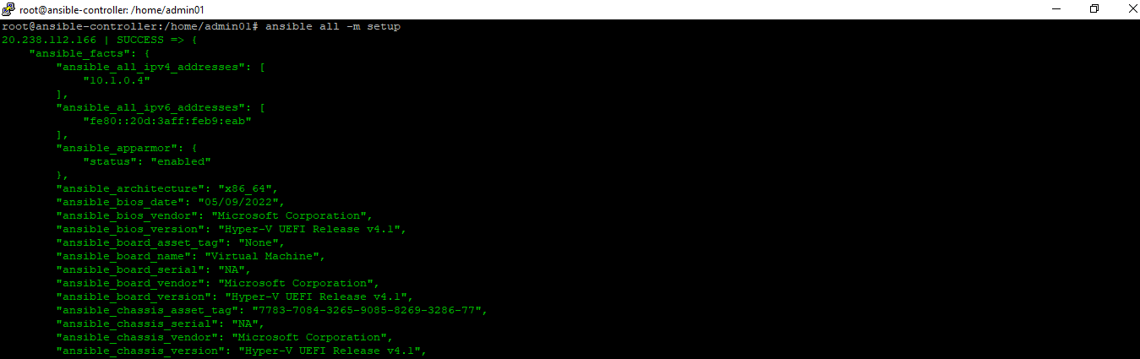

To gives the all the facts which are started with “facter_”

#ansible all -m setup -a 'filter=facter_*'

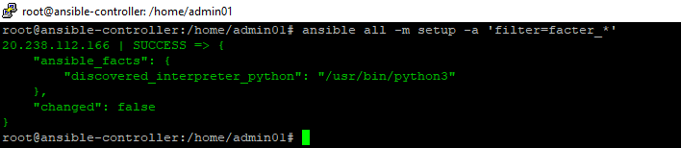

**Create a Playbook using yaml file:**

To create user by using following command:

#vi myfirstplaybook.yaml

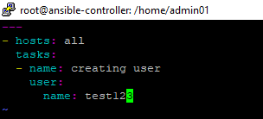

#ansible-playbook myfirstplaybook.yaml -b

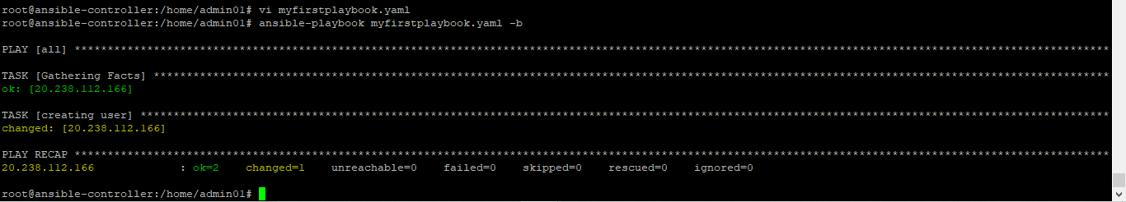

To run the myfirstplaybook.yaml playbook in more verbose

# ansible-playbook myfirstplaybook.yaml –b -vvv

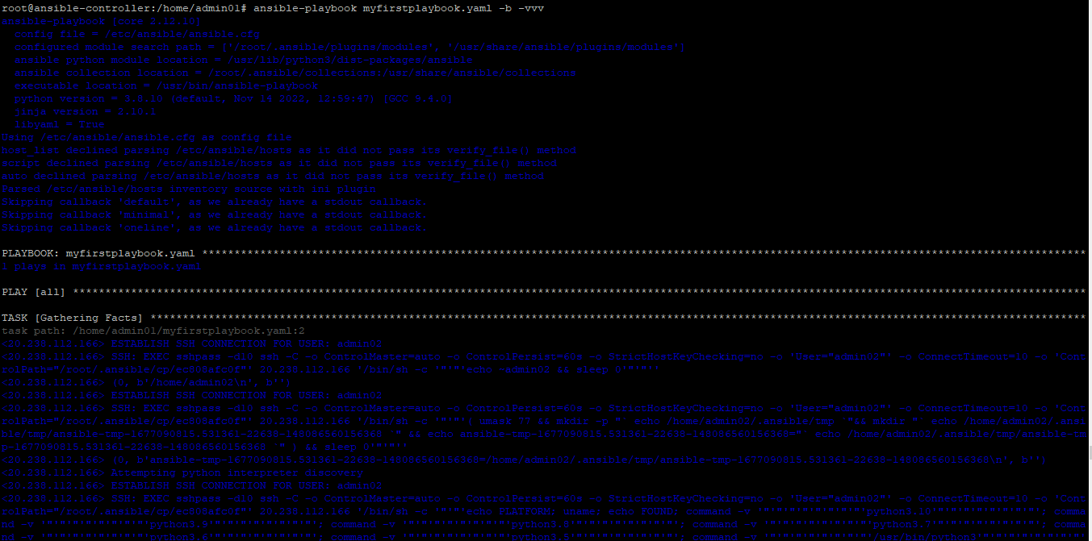

To create file by using following command:

#vi createfile.yaml

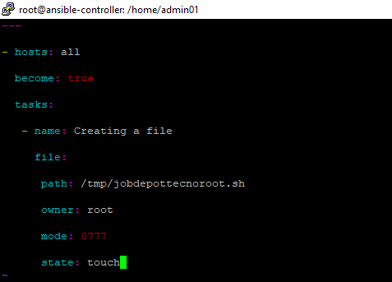

#ansible-playbook createfile.yaml

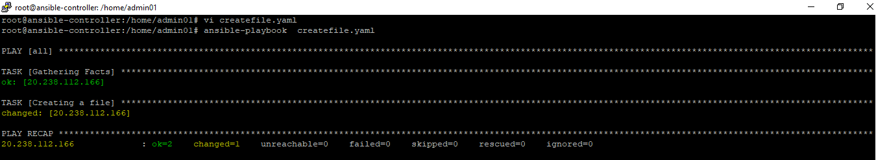

To run the createfile.yaml playbook in verbose

# ansible-playbook createfile.yaml –b –v

